CE’s notes on 29.8.2022

- See also comments in Tamoto 12/8/2022 email – in various pages.
- Last year this wasted lot of our time and in the end blamed the client that it is client who wanted to remain with existing panel.
- In terms of capacity, we can indicate 10% if the lead terms are found acceptable and subject to satisfactory replies to our various queries in Tamoto’s email of 12/8/2022.
- Is there any EQ sublimit for Domestic Inland Transit and Storage?
- Is the retention JPY 500,000,000 refers to loss retention and not the max SI retained.
__________________________________________________________________________________
- Retention increased from 300m to 500m
- Aggregate cover attaching point increased from 1500 to 2500
- EQ coverage under Section 1 increased from 1700m to 2000m – Is it in the aggregate or AOA
No more sublimit for EQ under Section 1 (Q4)
__________________________________________________________________________________
More questions on point 1 – See also comments in Tamoto 12/8/22 email – in various pages.

A1) Refer email - Ask what do they mean by “Russian Far East?” Is it now part of Russia or independent counties?”

Page 4 -- A2) Is Cedant buying any more reinsurance cover for the 2nd retention

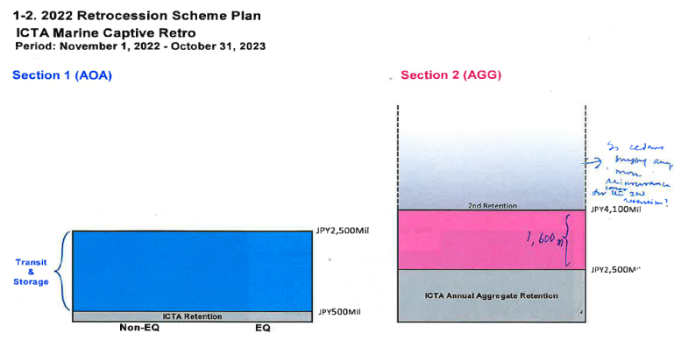

Page 4 -- A3) Is total aggregate recoverable under Section 1. Limited to JPY 2000m + JPY 2000m = JPY 4000m (Balance of one full reinstatement).

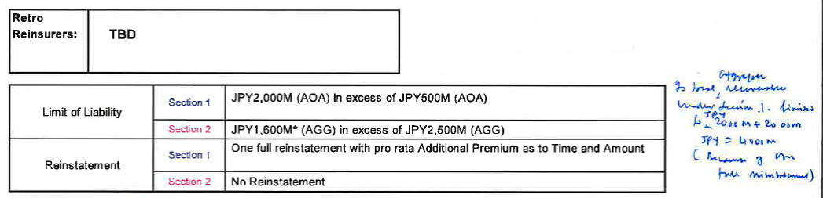

A4) Confirmation that under the 2022/2023 captive reinsurance there is no more EQ sublimit.

A5) Is 500m retention per bottom/per conveyance basis or per policy basis, irrespective of the number of policies in one vessel/conveyance.

A6) Is the maximum recoverable under Section 1 in JPY 2000million AOA plus 2000m being one reinstatement totalling to JPY 4000m in excess of JPY 500m AOA.

A7) Is the max recoverable under Section (2) in JPY 1600 million aggregate in excess of 2500m aggregate.

A8) On this basis of 500m retention (a) what is captive’s retained original gross premium. In ocean transit (b) Domestic transit and Stock Policy.

A9) What is the max retention of the captive on the domestic transit and stock policy.

Page 5 -- A10) Can they produce “incurred loss” statistics in the similar format.

Page 5 -- A11) Can they produce an “as if” statistics for captive retention increased from JPY 300m to 500m

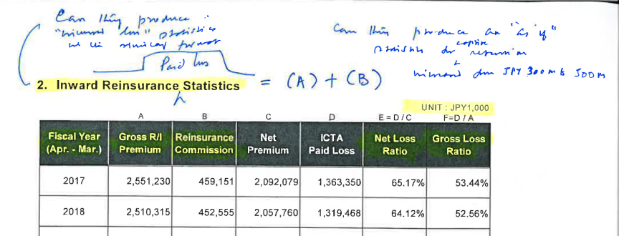

Page 6 -- A12) What would be the “as if” figures based on retention 500m

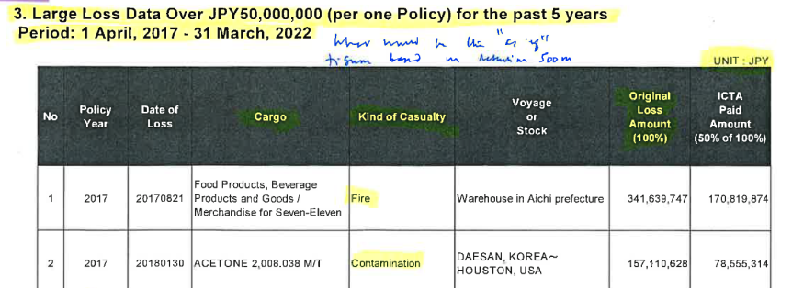
Page 6 -- A12i) How Jebi (DOL 4.8.2018) affects policy year 2021.?
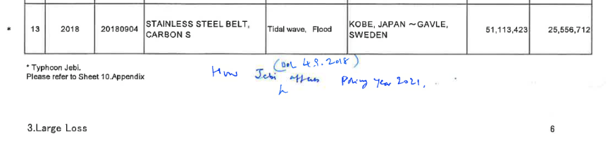

4. RETROCESSION ACTUAL RESULTS

Page 7 -- A13) On what basis this O/S adjustable additional premium calculated, why is this added to 2021 instead of 2017 the year affected by Jebi.

Page 7 -- A14) Can they provide “as if” retro claims statistics on the basis of 500m captive retention.

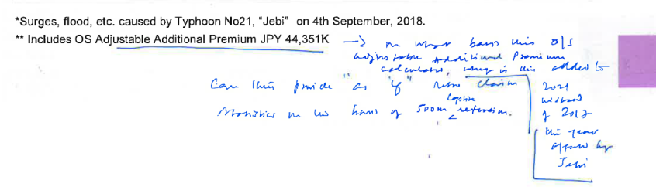
Page 9 -- A15) Is the captive reinsured amount set different for each type of cargo/each original insured.

Page 9 -- A16) When MSI, SJ, TM and other co-insurers are writing the original insured on coinsurance basis, would captive get a share from each co-insurer or only from his lead co-insurer.

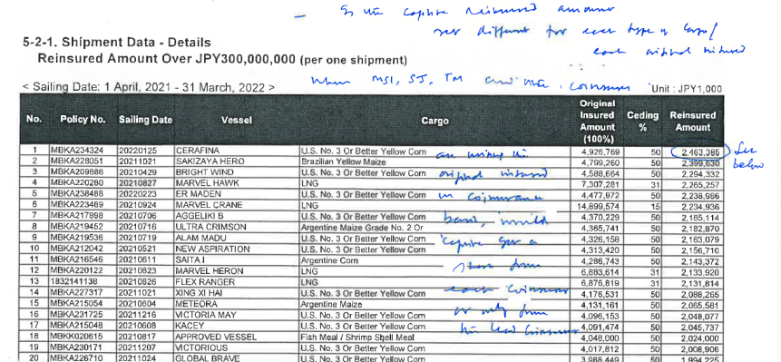

Page 9 -- A17) When the top sum reinsured is JPY 2,463,385,000, how do they deal with the balance amount? Difference between retention and above amount.
Are their percentage cessions decided at the start of the policy year depending on the cargo/original insureds.

Page 17 -- A18a) “Kokunai Togo Hoken” = What is the meaning of this words

Page 17 -- A18b) How do they deal with the difference between above amount and retention.
Page 18 – A19) Are they values for Captive Retention only?
Internal Notes to JIXIAN
Page 21 -- A20) Give Page 21 to Fac RI Dept and see how they mark Seismic Zone. Is it following their 12 Seismic Zone?

Page 23 - 8. Estimated Gross Net Premium
Page 23 -- A21) Is this for Captive Retained account GNPI? or for Captive gross account GNPI?
Page 23 -- A22) If it is Captive gross account, what is Captive’s retained account GNPI?
Page 26 -- A23) Why negative? Is it the estimated/anticipated recovery from the carrier/bailee.

Page 31 -- A24) What is the total?

